Project 2: Final Cloud Deployment Programmatic Approach Document
Matthew Santiago
University of Maryland Global Campus
CCS 640 Cloud Computing Implementations and Migrations
Charlie Shao
May 12, 2025

Executive Summary
BallotOnline is continuing to refine our cloud infrastructure to deliver scalable and secure operations during peak election times. This cloud deployment strategy uses Microsoft Azure as the main cloud provider all while ensuring we keep the ability to integrate with multiple cloud providers. We will review and discuss four programmatic tools: Chef, Azure Automation, Ansible, and Terraform. After that we will select the best solution to support multiple cloud platforms. The implementation of Azure Resource Manager (ARM) templates will be used for Azure deployments to maintain consistent and repeatable deployments. The proposed solution will satisfy BallotOnline's requirements for a scalable and secure network while maintaining cost efficient requirements. This automated approach will reduce human mistakes and ensure compliance is built into every deployment.
Plan Scope
Overview
This programmatic cloud deployment plan aims to create a standardized automated system for BallotOnline to deploy cloud infrastructure on Microsoft Azure with the ability to also transition or utilize other cloud providers. This plan focuses on scalability, security and compliance to maintain consistent infrastructure configurations throughout election cycles. This plan includes tool selection, deployment process and recommendations.
Cloud Configuration and Deployment Prerequisites
The prerequisite tools that can used to create ARM templates are ones that can edit JSON files. Microsoft recommends, “Visual Studio Code with the Azure Resource Manager Tools extension” (Microsoft, 2024). Also the use of PowerShell and connecting to Azure account with specific azure cmdlets (Microsoft, 2025).
Industry Leading Cloud Deployment Programmatic Approaches Overview
Programmatic approach is a way to manage cloud “resources from our development environments and manage by writing codes” (Ozkaya, 2022). While nonprogrammatic approach is manually managing the cloud resources through the cloud provider console, aka non script (Ozkaya, 2022). Through the use of CloudFormation or terraform one can grant these scripts access via IAM access keys in order to run and build our infrastructure while building in security requirements in the configurations to have a repeatable secure infrastructure (Amazon Web Services, n.d.). A programmatic approach favors building a new infrastructure. Lift and shift “enables the fastest time to production” (Amazon Web Services, n.d.) but this method only gets you up and running quickly and not taking full advantage of the cloud infrastructure. Once on a cloud platform, they recommend to architect application elements to leveraging cloud services (Amazon Web Services, n.d.) which will enable the efficient us of the programmatic approach. This approach will scale easily, because it is integrated with API calls and IAM access keys (Amazon Web Services, n.d.) It will scale as much as the organization needs. Using this approach will also allow the organization to scale quicker as well due to the ability to reduce human error and little to no manual input for infrastructure deployments.
Programmatic Cloud Deployment Tools
We will review 4 programmatic tools: Chef, Azure Automation, Ansible, and Terraform. The review will look at how these tools can be used for deploying and managing cloud resources that will support BallotOnline. The primary focus will be on using these tools on Microsoft Azure, but possible use with AWS. We will compare the tools by looking at function, usability, deployment and support. This report provide a comparison of the 4 programmatic approaches in order to choose the best tool for BallotOnline continued growth and expansion in the cloud.
Chef
Chef is a “automation platform that transforms infrastructure into code” (Progress Software Corporation, 2023). Chef uses the programming language Ruby for syntax for its cookbooks. The cookbooks contain recipes which are “blocks that define properties and values that map to specific configuration items” (Progress Software Corporation, 2023). Chef uses client-server set up which allows the server to become the hub for storing cookbooks, policy settings and saves historical configuration data (Progress Software Corporation, 2023). The cookbook that Chef provides is useful for organizations, not only can you find community cookbooks that can help in BallotOnline infrastructure development but BallotOnline can create its own and maintain throughout the years. The historical data feature is also interesting as you can pull the configuration data for a failed system to see what part in the configuration needs to be updated or modified leading to more refined infrastructure as time goes on. Chef also provides a test environment called Kitchen, to “automatically test cookbooks across any combination of platforms” (Progress Software Corporation, 2023). This test environment will help ensure the validity of the recipe file and identify issues with deployments before they are implemented for production use.
Azure Automation
Azure automation is a “cloud-based automation service that supports consistent management across your Azure and non-Azure environments” (Microsoft, 2025). Azure Automation uses Powershell to create desired state configurations (DSC) which is how infrastructure is deployed and configured (Microsoft, 2025). Azure automation also supports the ability to work with “physical servers and virtual machine outside of Azure, on your corporate network, or other cloud provider” (Microsoft, 2025). This feature is very useful for the migration of services to the cloud or a organization wanting to keep their data center in operation for compliance of data storage. Azure automation is a powerful tool that is versatile and can manage all aspects of cloud automation and work with BallotOnline physical servers to provide a flexible, controlled automation solution.
Ansible
Ansible is a open-source automation tool that states it will “let you automate virtually any task” (Ansible, 2025). Ansible uses scripts called playbooks to automate for local or remote systems and at the same time it helps keep the system stable. Another plus to this tool is that it is agentless, which gets rid of the need to install software on infrastructure to automate them (Ansible, 2025). Also because Ansible is open source this reduces the cost associated with other tools while providing the ability to use as a tool that can move between cloud providers, not locking BallotOnline into provider lock.
Terraform
Terraform is a “infrastructure as code tool that lets you define both cloud and on-prem resources in human-readable configuration files” (HashiCorp, n.d.). Terraform also provides a registry of templates to be used for various cloud providers. Terraform not only creates infrastructure but will allow for easily tracking and changing the infrastructure (HashiCorp, n.d.). Terraform has a big use with various organizations and is well documented which is great for learning and getting help with specific issues. Terraform also allows for tracking of the infrastructure in a state file which will allow BallotOnline to know the true state of the infrastructure and changes made (HashiCorp, n.d.).
Comparison
Tool | Function | Usability | Deployment | Support
Chef | client-server model for transforming infrastructure into code (Progress Software Corporation, 2023) | Need to know Ruby. (Progress Software Corporation, 2023) | Client-server (Progress Software Corporation, 2023) | Strong community (Progress Software Corporation, 2023)
Azure Automation | Cloud-based automation for Azure and non-Azure environments (Microsoft, 2025) | Need to know powershell (Microsoft, 2025) | Azure integration (Microsoft, 2025) | Azure documentation (Microsoft, 2025)
Ansible | Open-source with agentless automation (Ansible, 2025) | Need to know YAML (Ansible, 2025) | Agentless with multiple cloud providers (Ansible, 2025) | Large open-source community (Ansible, 2025)
Terraform | Infrastructure as code for cloud and on-premises infrastructure. (HashiCorp, n.d.) | Need to know the simplified coding for Terraform. (HashiCorp, n.d.) | Multiple cloud providers support terraform (HashiCorp, n.d.) | Strong community support, well-documented (HashiCorp, n.d.)

The usability of each tool is straight forward and they all have a community behind them and documentation to quickly get started. Chef would be the most difficult to get started due to client server model, which needs software installed on all the infrastructure nodes being managed. Also, chef requires Ruby programming language which is a niche language that will require training for staff. Azure Automation is cloud based not requiring software installed and Powershell language which most system administrators know already. This leads to a quickly deployable system that could help the automation of our cloud but if BallotOnline doesn’t choose to use Azure it will be cumbersome to use that tool even if it can integrate with other cloud providers. Ansible is a good choice due to open-source, agentless model and ability to integrate with multiple cloud providers. Ansible uses known YAML files and has a large community for troubleshooting. Terraform is infrastructure as a code and can be written to deploy, manage and track infrastructure. Terraform integrates with cloud providers and is simple to read, write and deploy. Depending on BallotOnline requirements a single solution that can be used to deploy and manage cloud infrastructure on multiple clouds is necessary so our employees can learn a simple tool that will work were ever we decide to deploy our infrastructure.
In summary, all 4 automation tools are capable of providing the capabilities BallotOnline is looking for but with varying degrees of learning. In order to narrow it down, I believe BallotOnline should consider Ansible or Terraform because these tools provide multi-cloud integration, ease of use, and strong community to support troubleshooting. Ansible with its agentless model and it being open-source offers a cost effective solution while Terraform state tracking and simplified coding enable scalability and clarity for infrastructure management.
Azure ARM Templates
Overview
ARM templates are “JavaScript Object Notation (JSON) file that defines the infrastructure and configuration for your project” (Microsoft, 2025). ARM templates “allow you to create and deploy an entire Azure infrastructure declaratively” (Microsoft, 2025). This leads to repeatable results. This is beneficial for when BallotOnline needs to deploy infrastructure during election cycles for the network and VMs to be the same and run the same over and over again for different elections. ARM templates can be used to deploy resources across multiple regions as well. In this situation we need to break the template into many related templates linked together by a main template (Microsoft, 2025). Through the use of linked and nested templates that call back to the main template a deployment across multiple regions is possible.
Prerequisites
ARM Templates are JSON files so users need to understand basic JSON to work with templates (Microsoft, 2025). Microsoft recommends, “Visual Studio Code with the Azure Resource Manager Tools extension” (Microsoft, 2024). The ARM Template Test Toolkit serves is also recommended to check templates against recommended standards before deploying them (Microsoft, 2025). 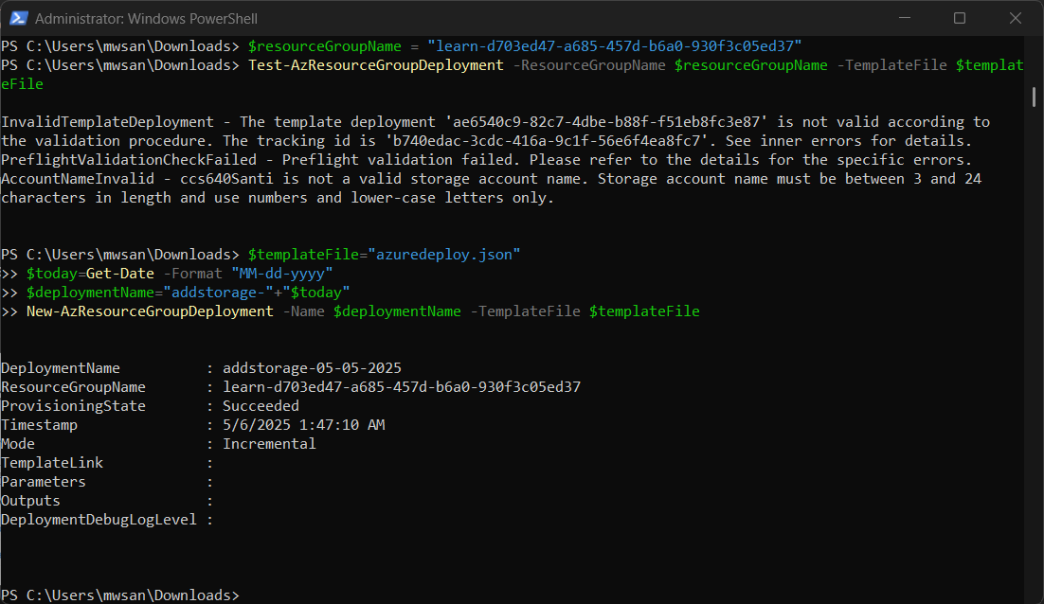
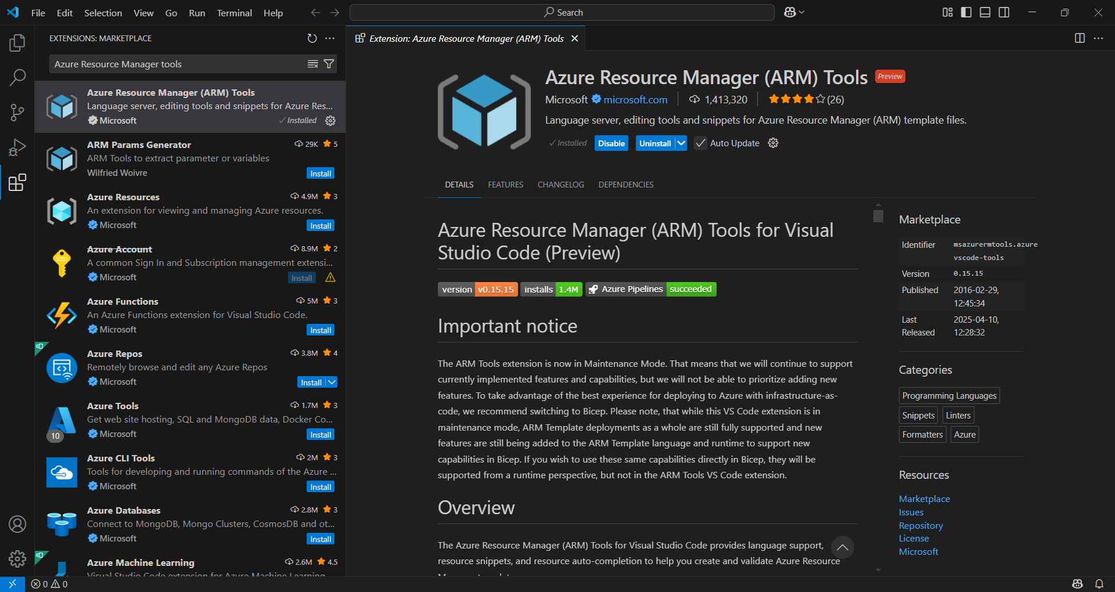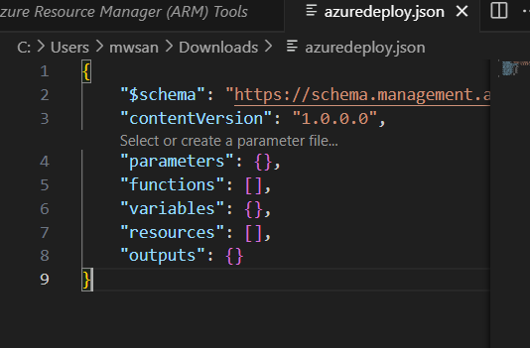
Evaluation
ARM templates “allow you to create and deploy an entire Azure infrastructure declaratively” (Microsoft, 2025). This leads to repeatable results. This is beneficial for when BallotOnline needs to deploy infrastructure during election cycles for the network and VMs to be the same and run the same over and over again for different elections. Through the use of linked and nested templates that call back to the main template a deployment across multiple regions. Managing templates can be done through the Azure portal to track the deployments and using the pre-built policy and blueprint code in order to ensure regulatory and compliance standards are met (Microsoft, 2025). Though ARM templates can also be added to GitHub as well and that is another way to effectively manage templates (Microsoft, 2025).
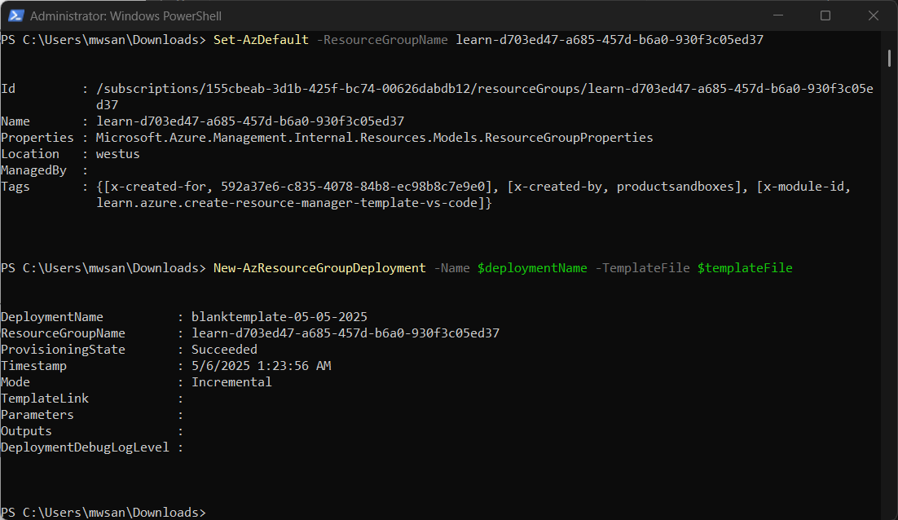
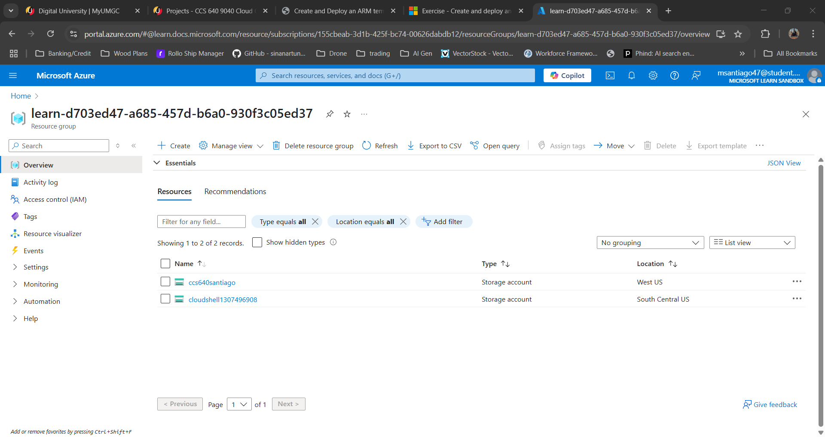
Programmatic Cloud Deployment Scalability Recommendations
Using a programmatic approach to develop BallotOnline's cloud infrastructure is nessecary for efficient and consistent deployments. It is our recommendation that BallotOnline uses Terraform for Programmatic Cloud Deployments. Terraform is an “infrastructure as code tool that lets you define both cloud and on-prem resources in human-readable configuration files” (HashiCorp, n.d.). Terraform enables the tracking of the infrastructure in a state file which will allow BallotOnline to know the true state of the infrastructure and changes made (HashiCorp, n.d.). By using Terraform configurations BallotOnline will create reusable templates to deploy and modify the cloud infrastructure. The recommendation for terraform is made because terraform is not azure specific and can be used with several cloud providers which will enable our employees the ability to replicate the network on other cloud providers if needed. This option keeps Ballot online from being locked into a specific cloud provider and provides multi cloud integration for future operations.
Conclusion
In conclusion, using a programmatic approach to cloud deployments is necessity to ensure consistent and quickly deployable infrastructure. While Microsoft azure offers ARM templates, which are easy to read and write and deploy on Azure it is specific only to Azure and would cause vendor lock in. The use of Terraform which provides the same and or better functionality then ARM templates and is also easily read/write for employees make it the best choice for long term single or multi cloud operations.

References
Amazon Web Services. (n.d.). Lift-and-Shift Application Workloads. Retrieved from Amazon Web Services: https://aws.amazon.com/products/storage/lift-and-shift/
Amazon Web Services. (n.d.). Programmatic access with AWS security credentials. Retrieved from Amazon Web Services: https://docs.aws.amazon.com/IAM/latest/UserGuide/security-creds-programmatic-access.html
Ansible. (2025, APR 23). Introduction to Ansible. Retrieved from Ansible Community Documentation: https://docs.ansible.com/ansible/latest/getting_started/introduction.html
HashiCorp. (n.d.). What is Terraform? Retrieved from Terraform: https://developer.hashicorp.com/terraform/intro
Microsoft. (2024, JUN 20). Tutorial: Create and deploy your first ARM template. Retrieved from Learn: https://learn.microsoft.com/en-us/azure/azure-resource-manager/templates/template-tutorial-create-first-template?tabs=azure-powershell
Microsoft. (2025, APR 28). Deploy resources with ARM templates and Azure PowerShell. Retrieved from Learn: https://learn.microsoft.com/en-us/azure/azure-resource-manager/templates/deploy-powershell
Microsoft. (2025, APR 28). Use ARM template test toolkit. Retrieved from Learn: https://learn.microsoft.com/en-us/azure/azure-resource-manager/templates/test-toolkit
Microsoft. (2025, APR 28). Using linked and nested templates when deploying Azure resources. Retrieved from Learn: https://learn.microsoft.com/en-us/azure/azure-resource-manager/templates/linked-templates?tabs=azure-powershell
Microsoft. (2025, JAN 29). What are ARM templates? Retrieved from Learn: https://learn.microsoft.com/en-us/azure/azure-resource-manager/templates/overview
Microsoft. (2025, APR 24). What is Azure Automation? Retrieved from Microsoft Learn: https://learn.microsoft.com/en-us/azure/automation/overview
Ozkaya, M. (2022, MAR 12). AWS Access Types — Programmatic and Management Console Access. Retrieved from Medium.com: https://medium.com/aws-serverless-microservices-with-patterns-best/aws-access-types-programmatic-and-management-console-access-134cb4ea2d2a#:~:text=1%2D%20AWS%20Management%20Console%20Access,and%20manage%20by%20writing%20codes.
Progress Software Corporation. (2023, OCT 19). Chef Infra Overview. Retrieved from Progress Chef: https://docs.chef.io/chef_overview/

